1. Create an html page to display the following nested list  
   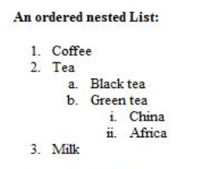
2. Create links to three different pages on three different websites that should all open in a new window.
3. Create a page with a link at the top of it that when clicked will jump all the way to the bottom of the page.
4. Display three different images. Skip two lines between each image. Each image should have a heading.
5. Display an image that when clicked will link to a search engine of your choice in a different window
6. Create the following Html Page using appropriate form controls

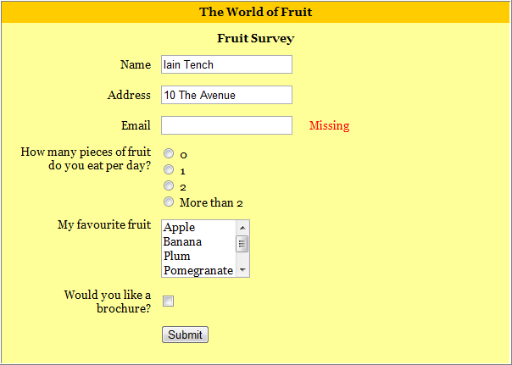

1. Create an image map for ‘Kerala Map’. Map at least 3 districts so that when you click on that particular district the details regarding that district(**eg: population, Area, Tourist Spots(with images), Monuments, Interesting Facts )** should be displayed on a new page.
2. Construct this puzzle looking thing

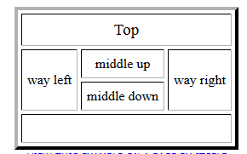

1. Make up three image links for 3 web browsers and put them in a borderless table. Construct the table so that there is just a little space between the images.

1. **Create the following html page using frames**

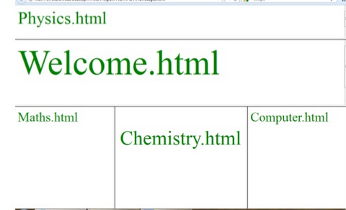

1. **Create an HTML page using frames which is similar to the following one.**

**In the left frame provide hyperlinks to 3 important monuments in world. On clicking that hyperlink an image of the monument should be displayed in right frame with suitable description**

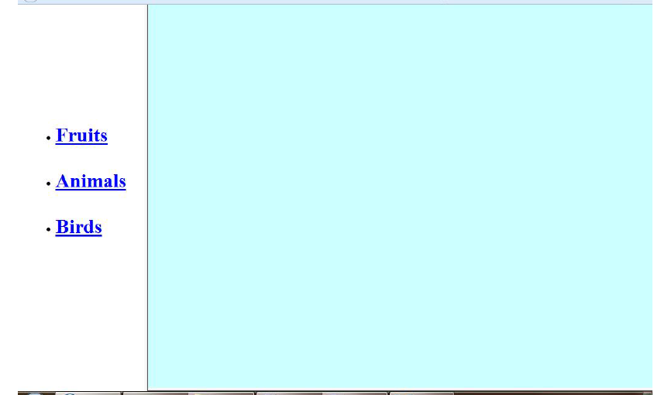

<table border=”1’ width=”100%” hight=“100%” bgcolor=”red”>

</table>

|  |  |
| --- | --- |
| name | <input type =””> |
| adresss |  |
|  |  |
|  |  |
|  |  |
|  |  |
|  | <input type= “button”> |